Landscape References
By
www.LarryLandscapeS.com

623-329-3169

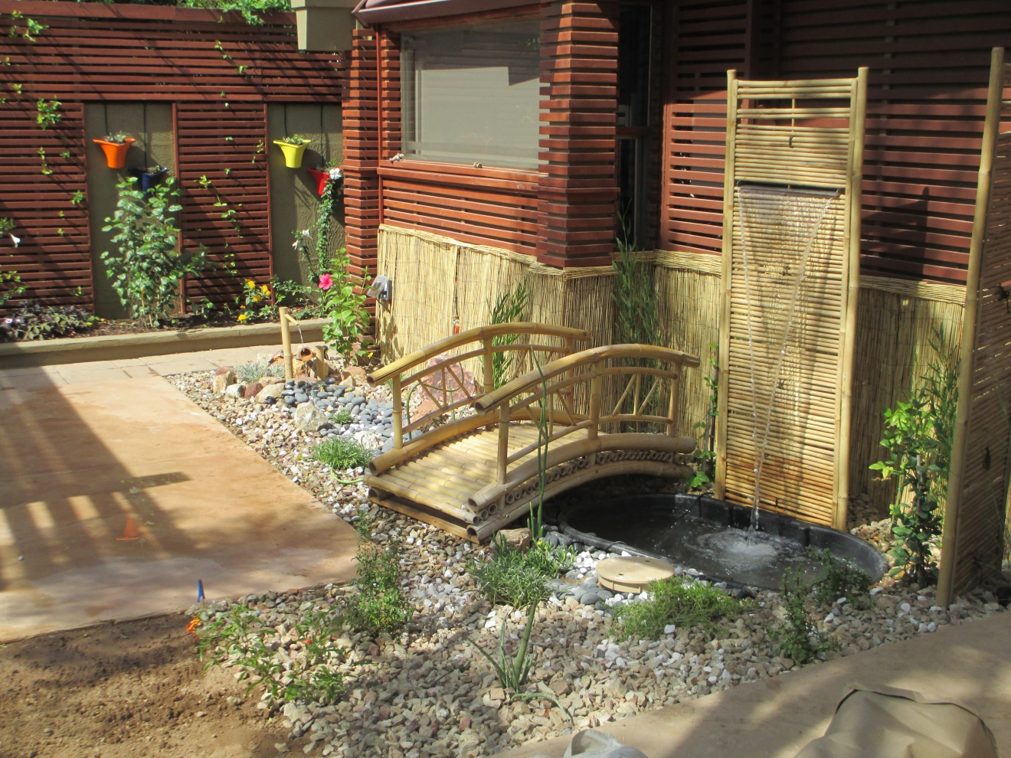

The following families and home owners have hired me to perform their Landscapes and are glad to receive your call to review my professionalism, how I conduct myself and the quality I perform. Every job is different. I always take into consideration many factors to produce the look and feel required by my client. Sometimes a “Vision” is my talent not revealed until the Landscape actually begins to grow and take shape as it matures. I will not alert these folks that you may inquire bout me, but all are good people & probably won’t mind a chat

Most Recent:
Isabell & Federic Ayvaz
13306 W. San Miguel Ave.
Litchfield Park
623-760-7576 (Isabell)

Really good folks. Fun to work with, Demanding in a sense that they knew what they wanted. Here is the result of our good working relationship.

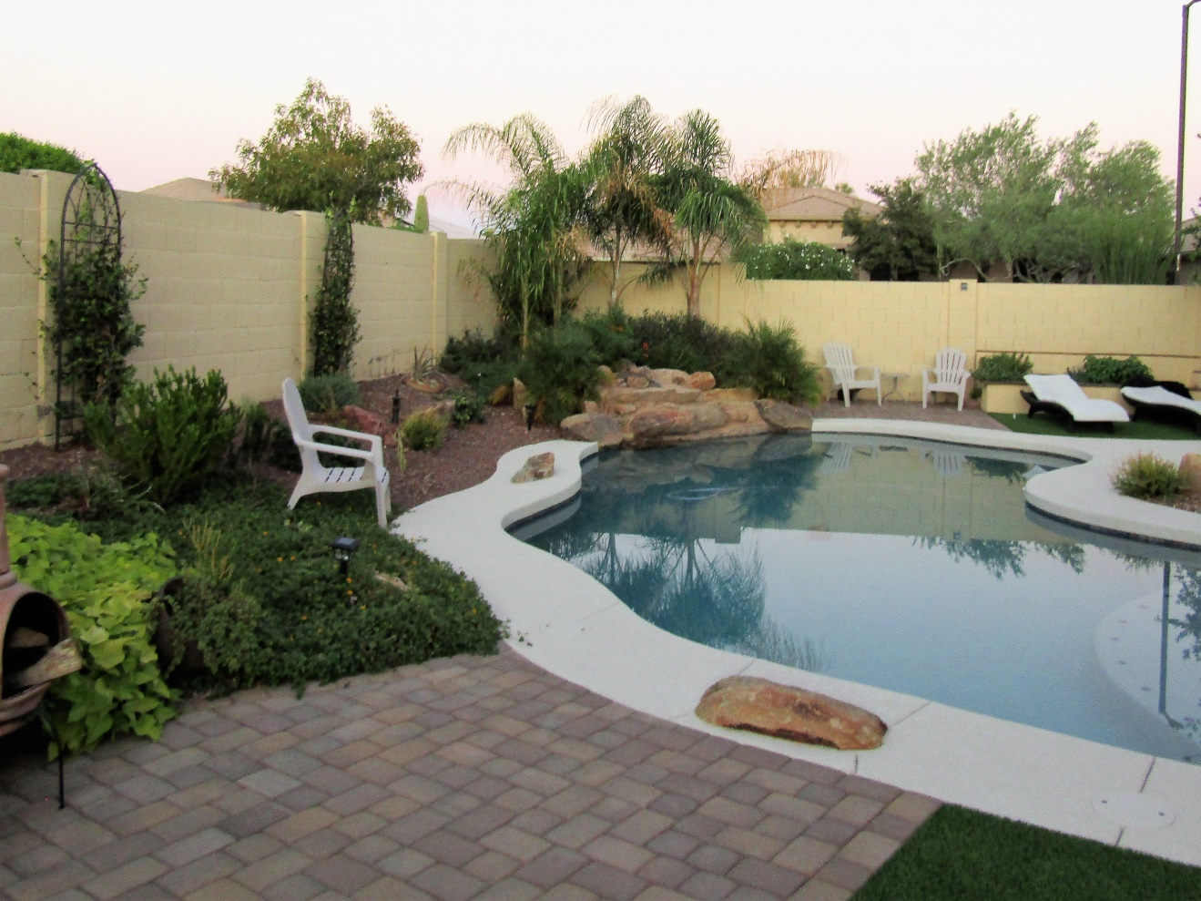
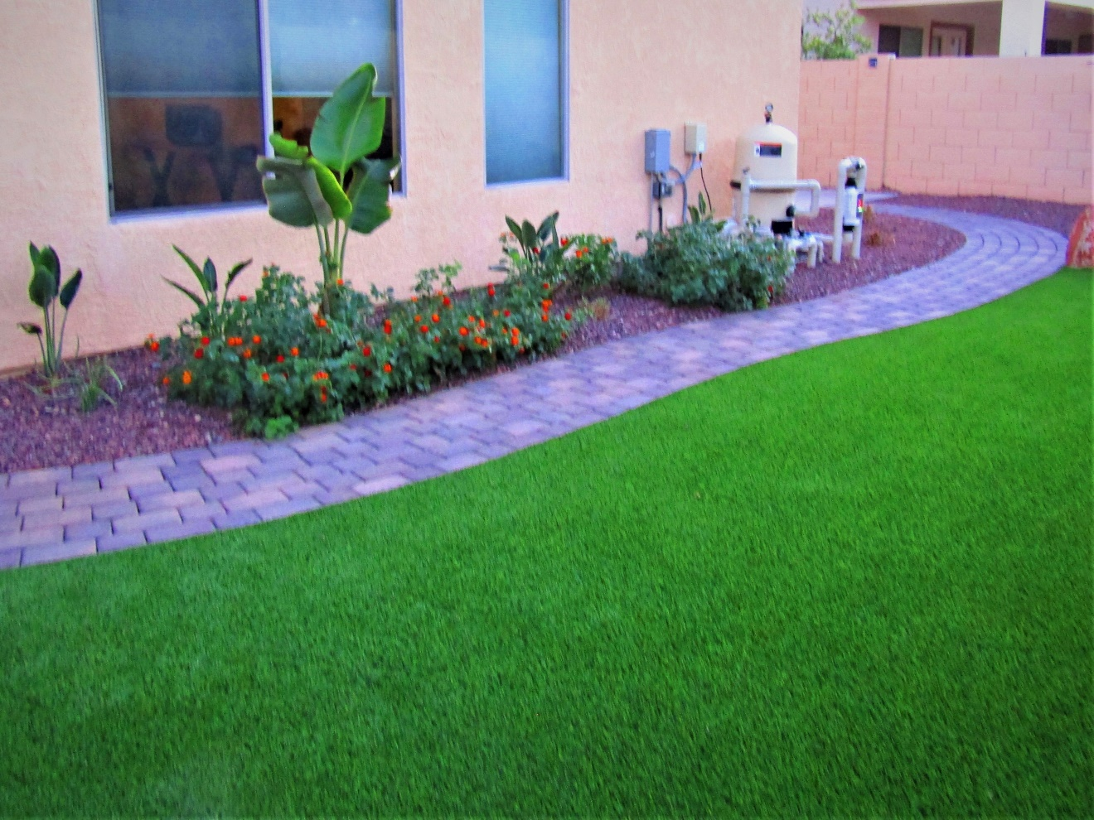

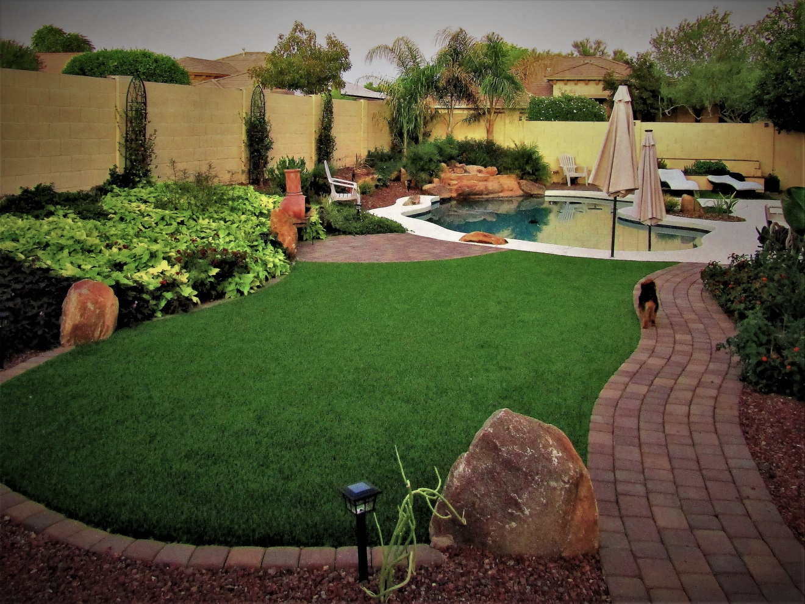

Guy & Kim Zamudio
10235 w. Mariposa Grande
Peoria, Az. 85342
602-525-1554 Guy (text)
602-525-1556 Kim (text)

Guy and Kim were amazed that I paid so much attention to detail. This was a project that reaped a new friend and some of my best work. We have a few different phases as budget allows.

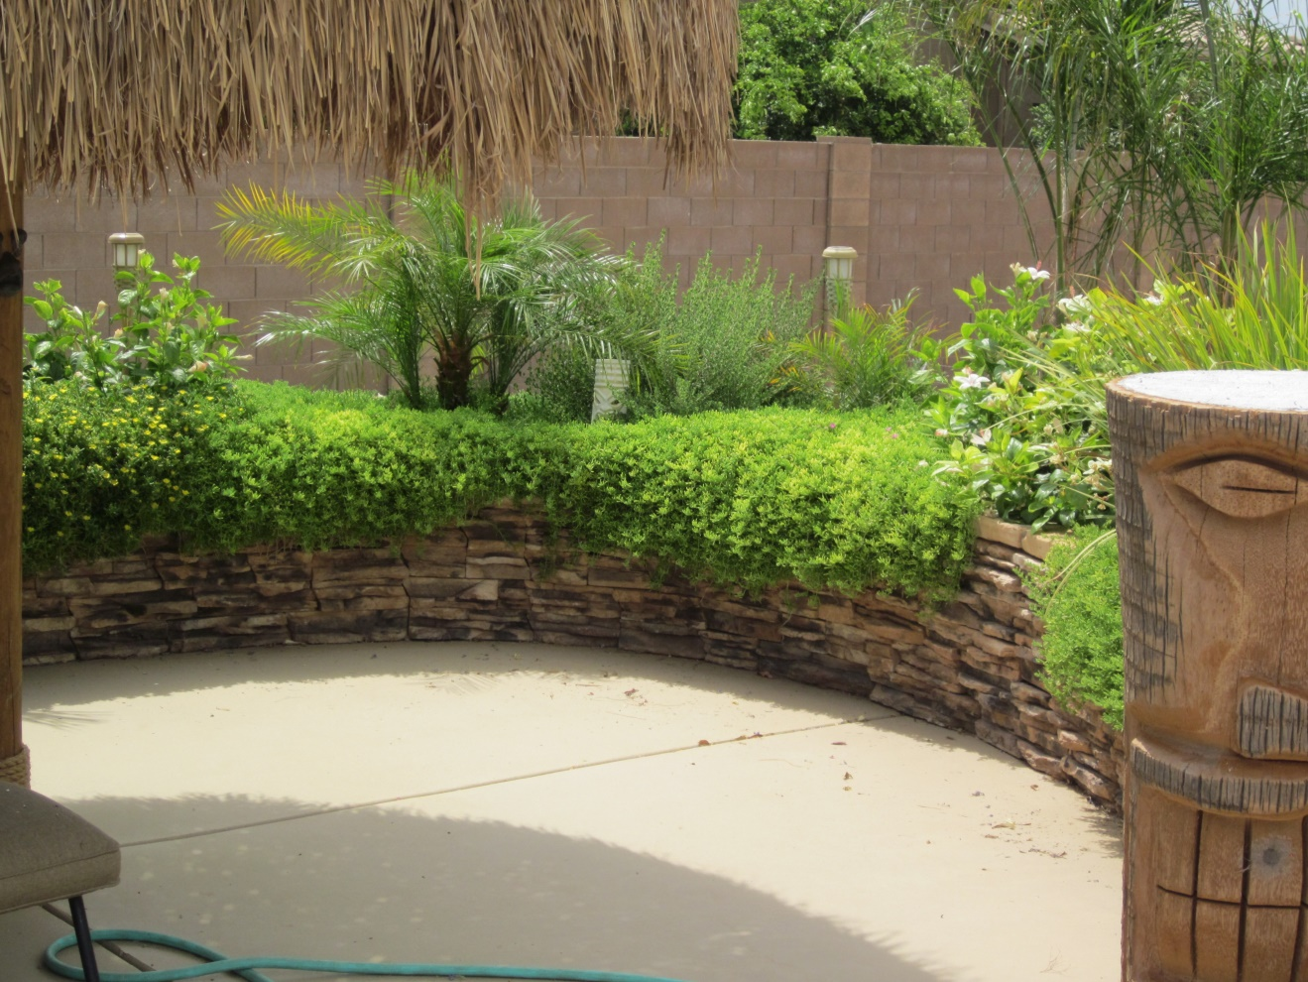

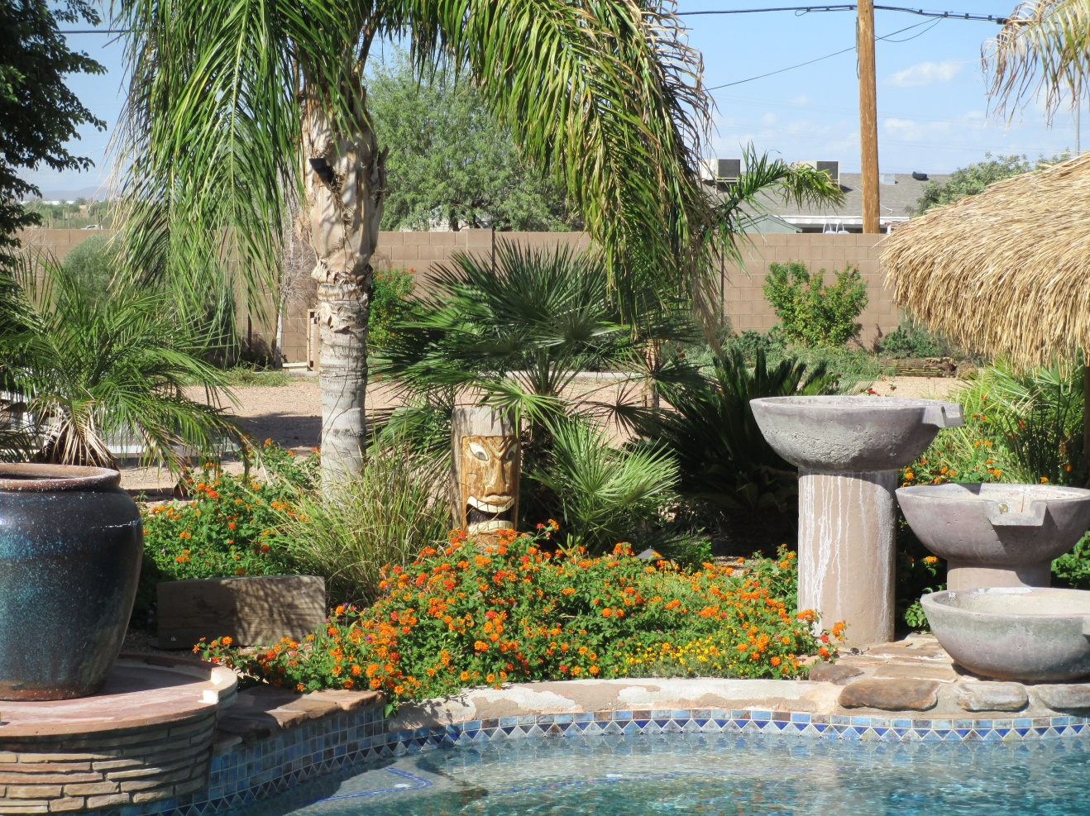
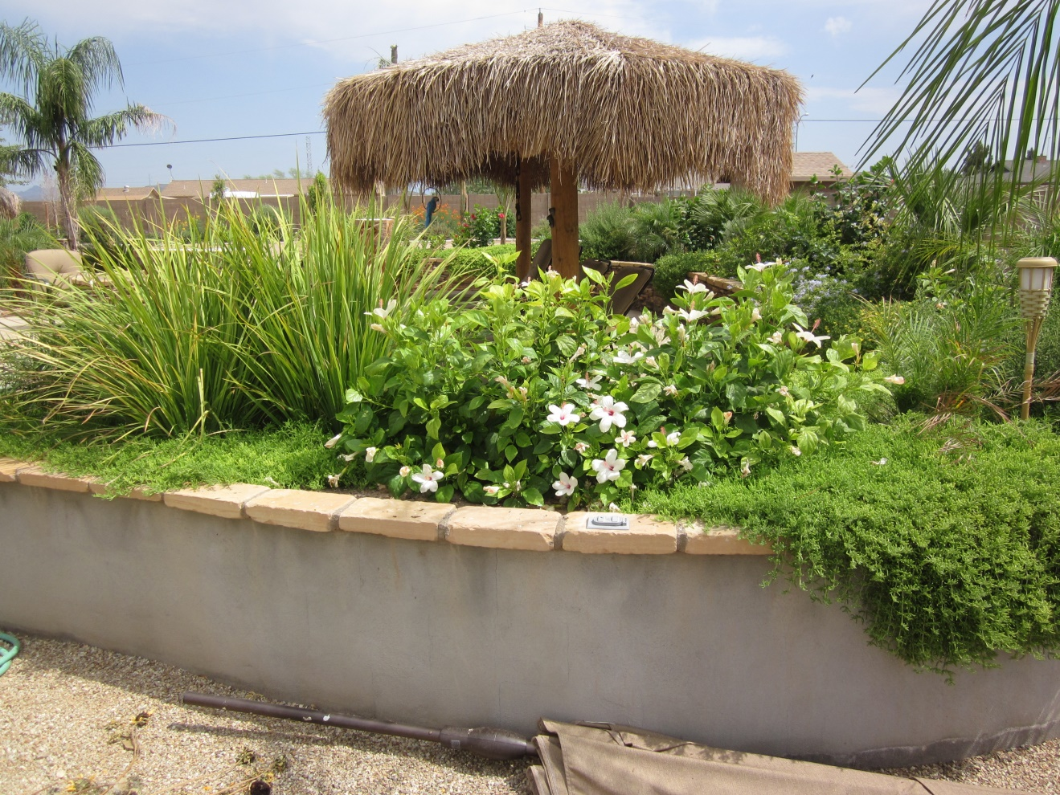
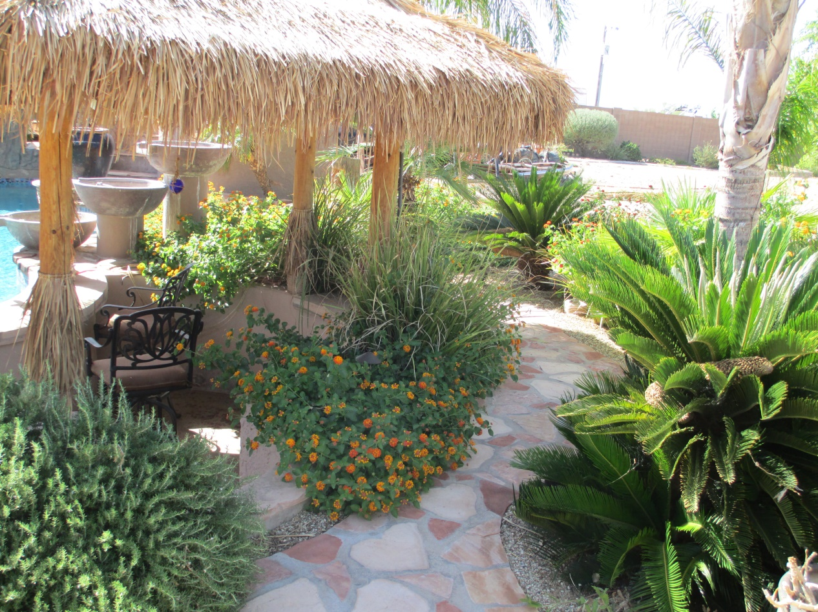

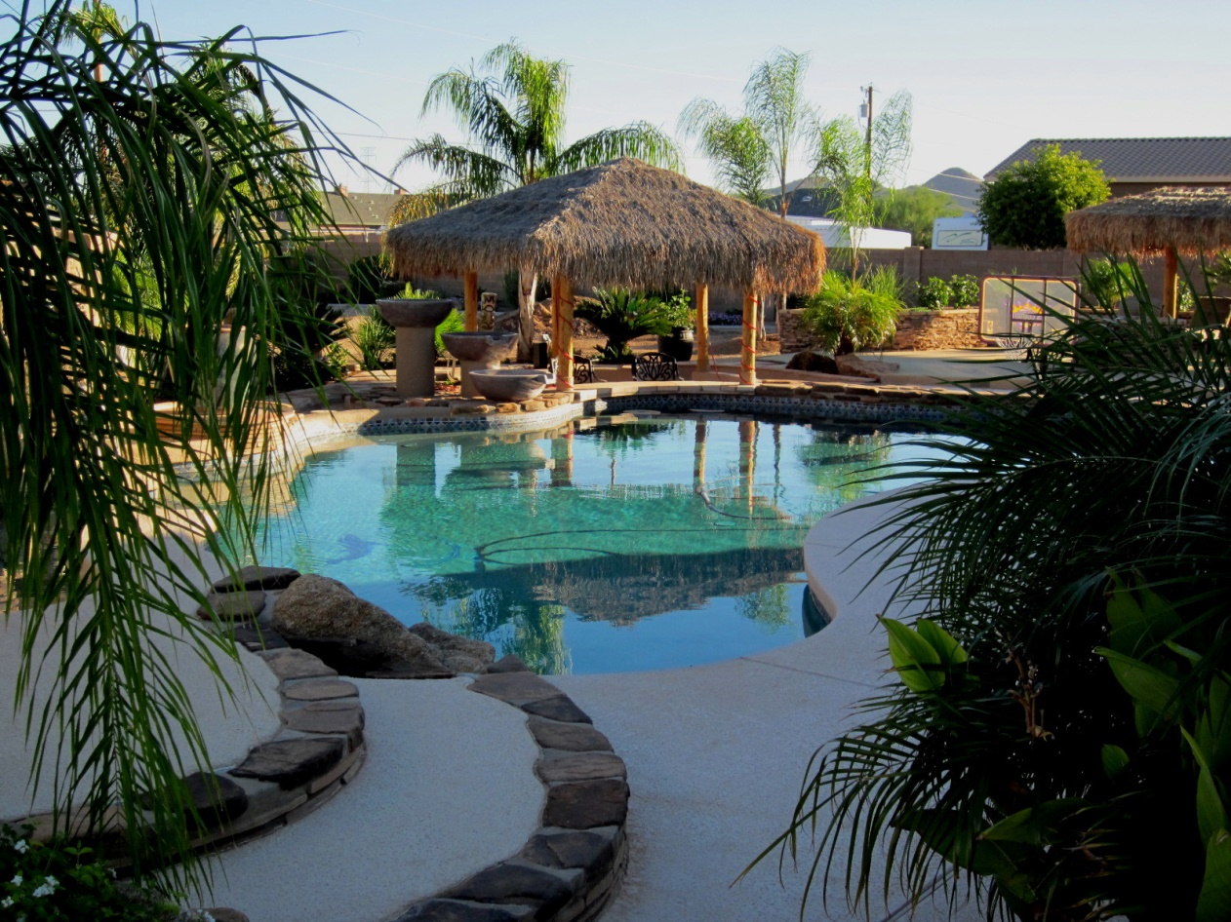
Mr. & Mrs. Pace Morby
3285 E. Franklin Ave.
Gilbert, Arizona 85295

Pace and his wife Jess were tickled to finally have the nicest yard of family & Friends. Lots of Pavers, Trees, 12 Pygmy Palms with island in the grass. Fire pit with seating and Flagstone cap. WOW- it was a blast to build this one. Herein, I will show pictures of the process as it all fell together.

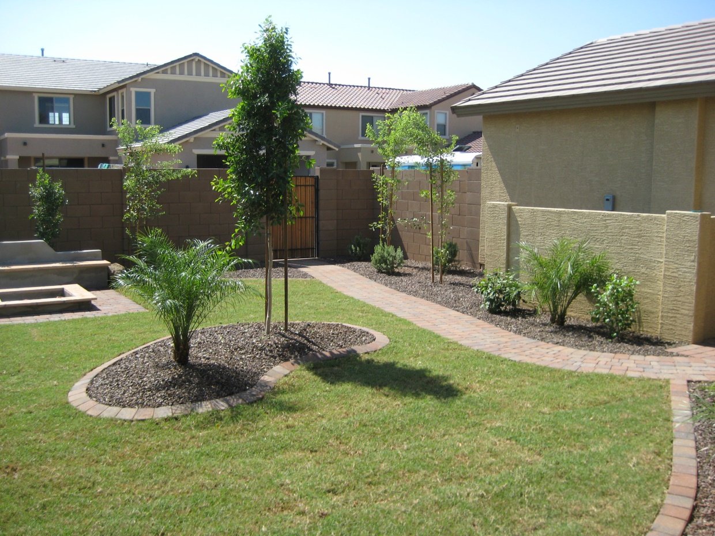
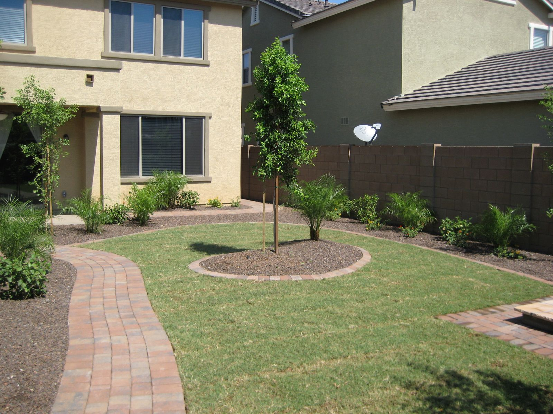
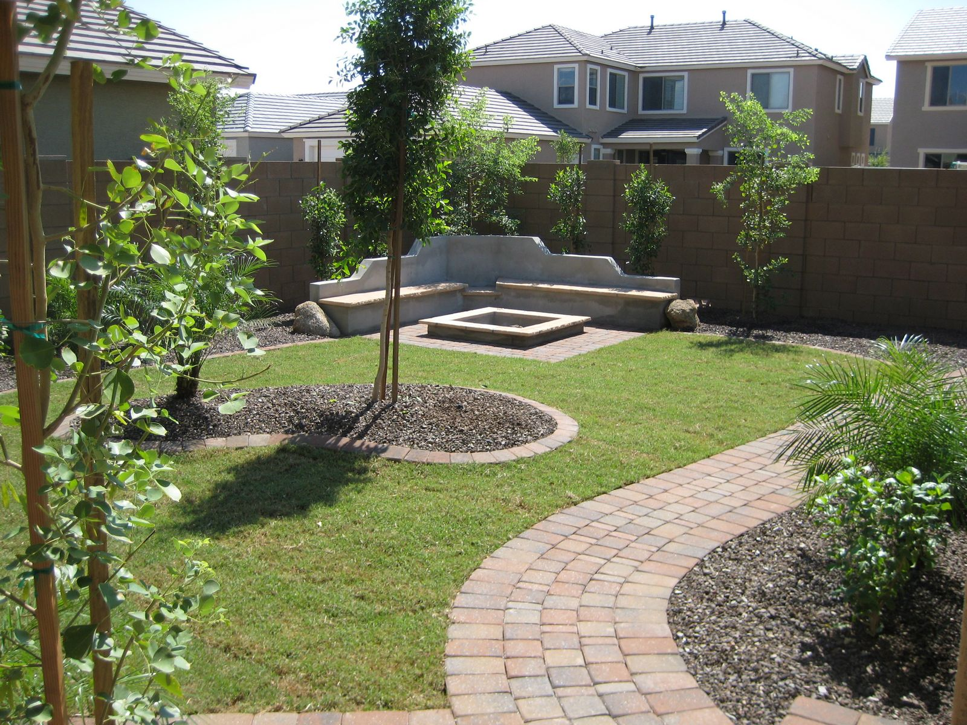

John Paul
16241 N 91st Ave
Peoria, AZ 85381
602-301-9632
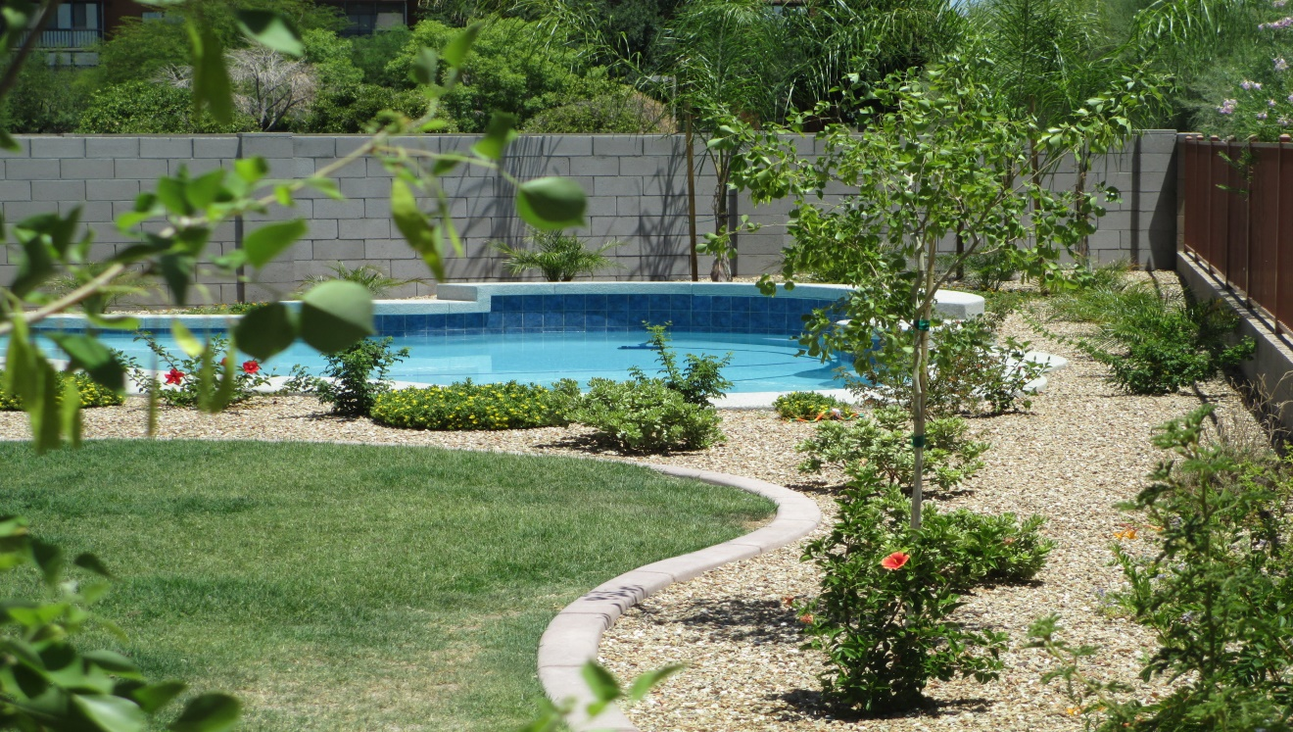

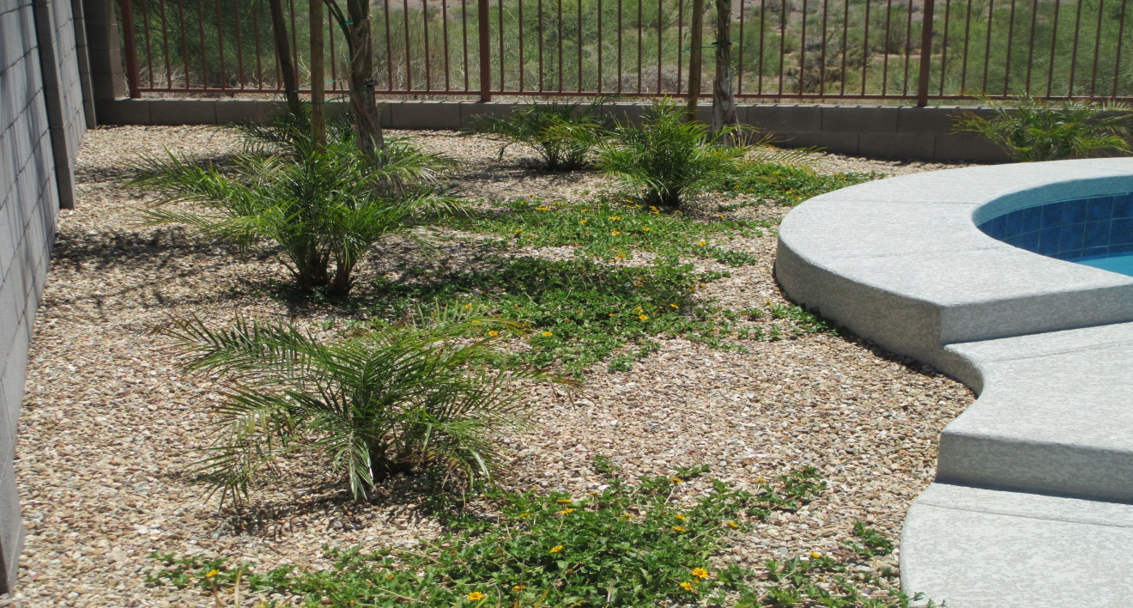
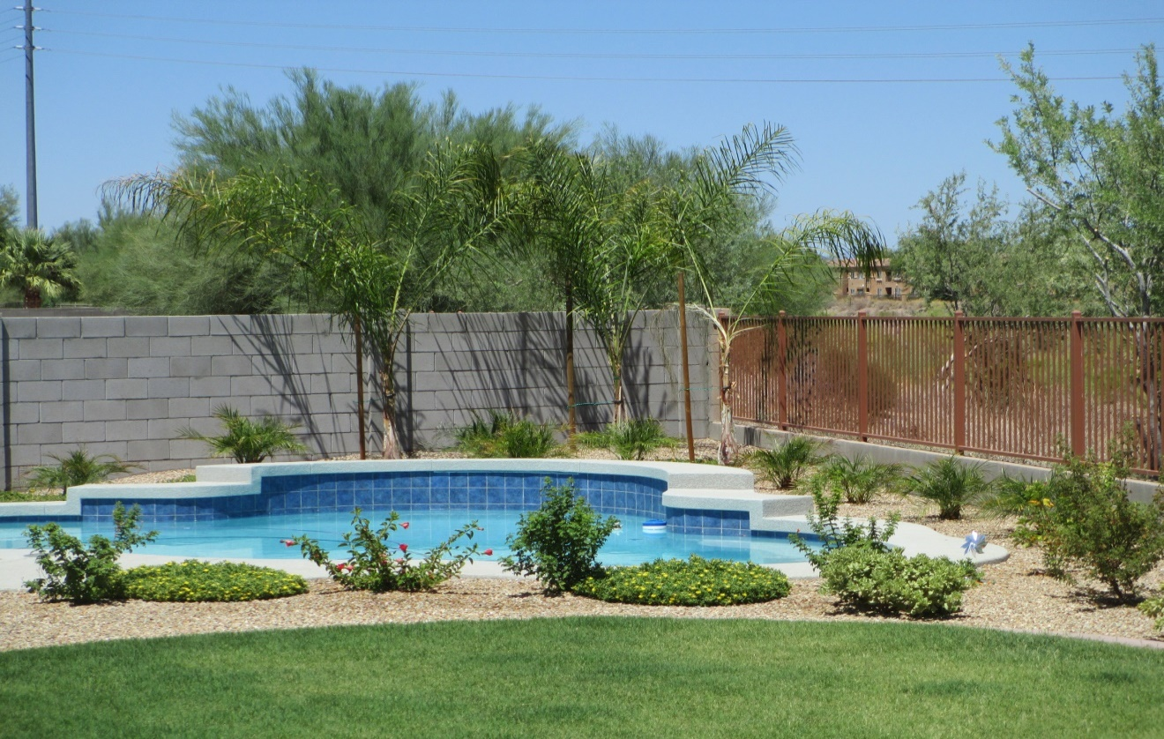

Rodney & Debra Toles
15063 W. Charter Oak Rd.
Surprise AZ. 85379
480-236-9273
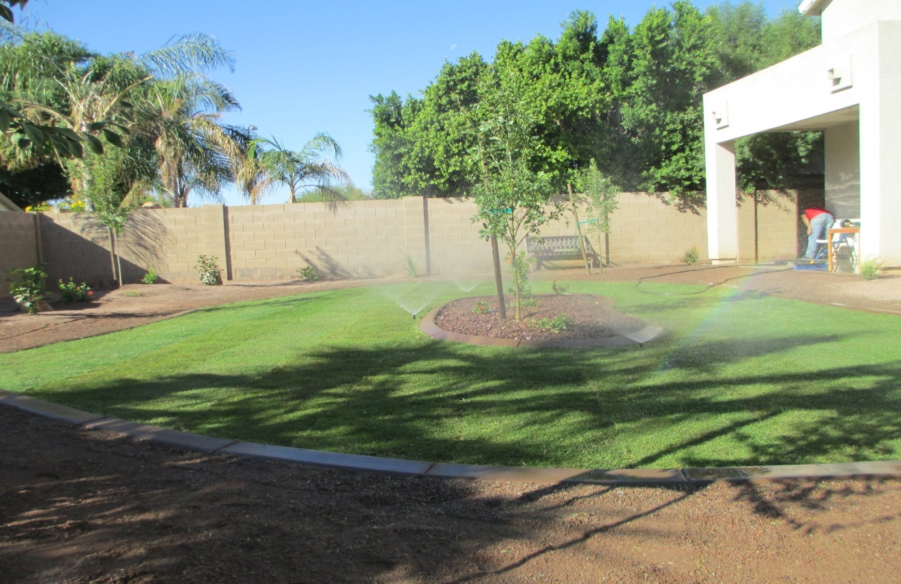

Sue & Bud
New Build
Pinnacle Peak/Lake Pleasant Pkwy

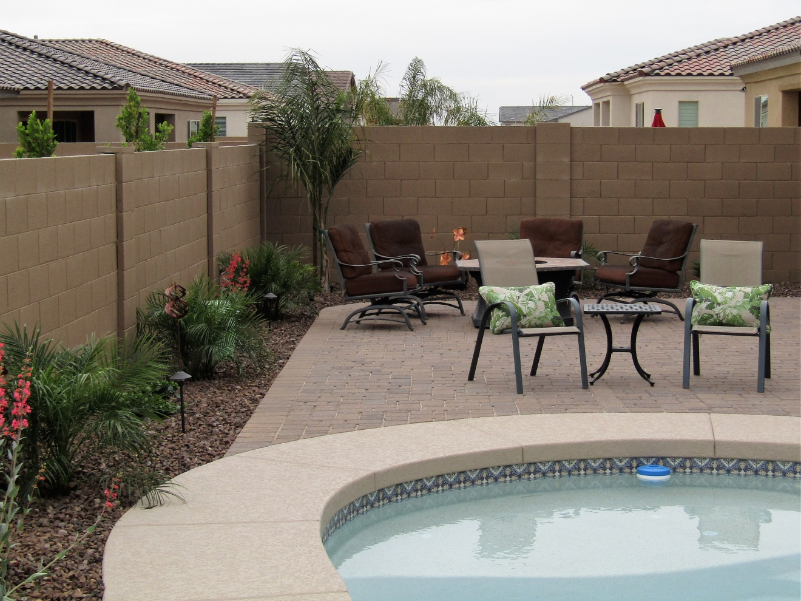
We added Pavers & Landscape to finished pool. A nice lady; she chalenged me every step of the way. It turned out Exactly how she wanted.

Jim & Kirstie
Paradise Valley
Owner D.B.S. I. Construction Co.

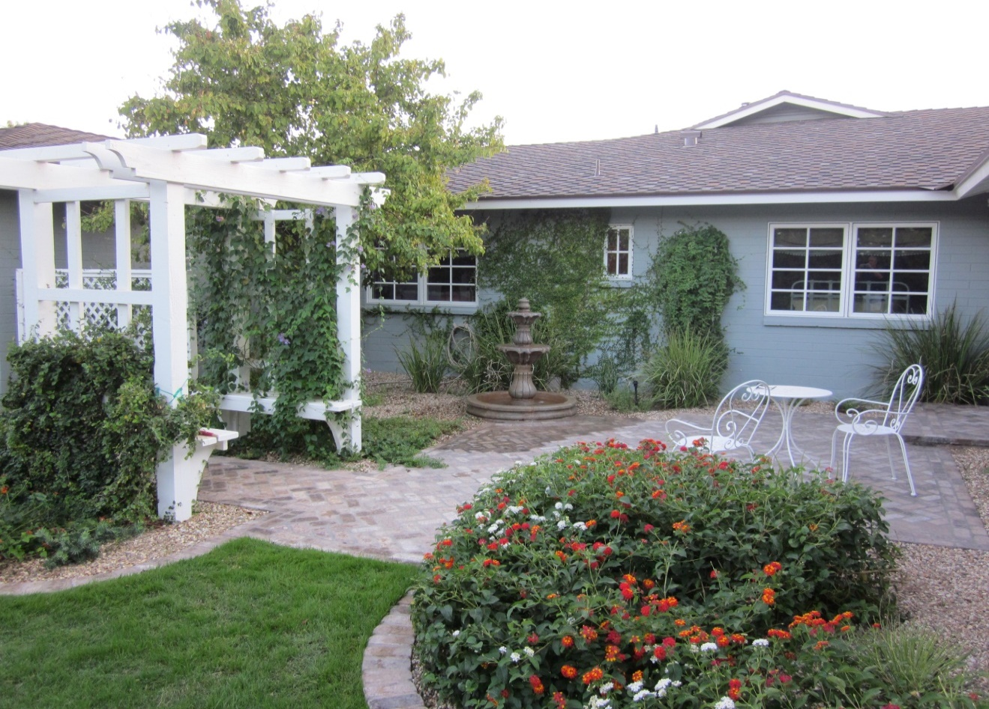
A 100% renovated Paradise Valley Home. Not 1 sq. ft. inside & out was missed.
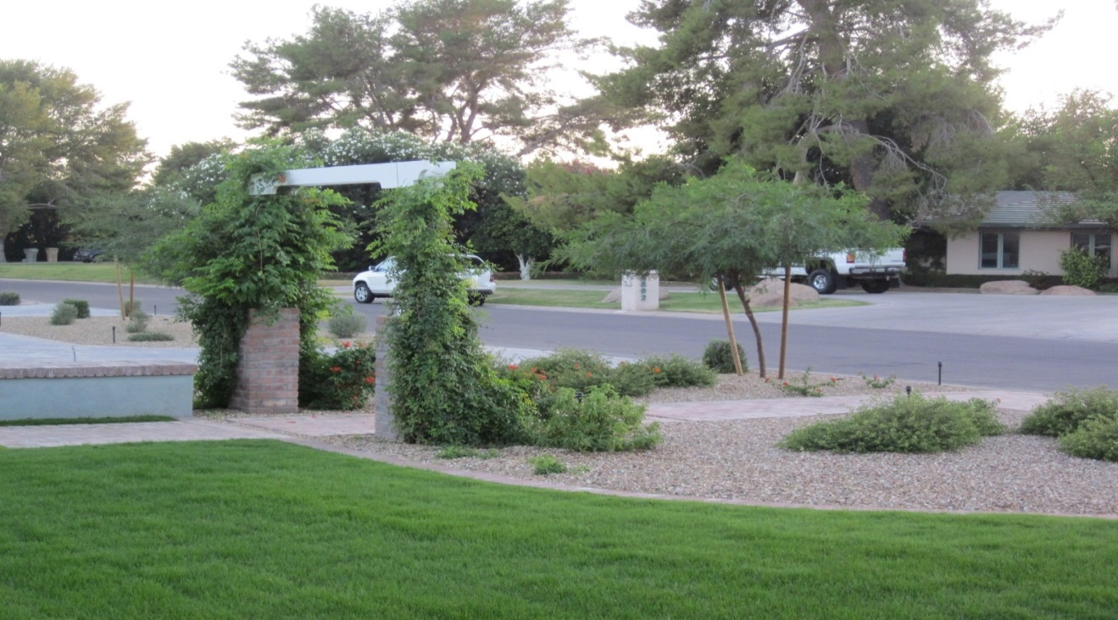

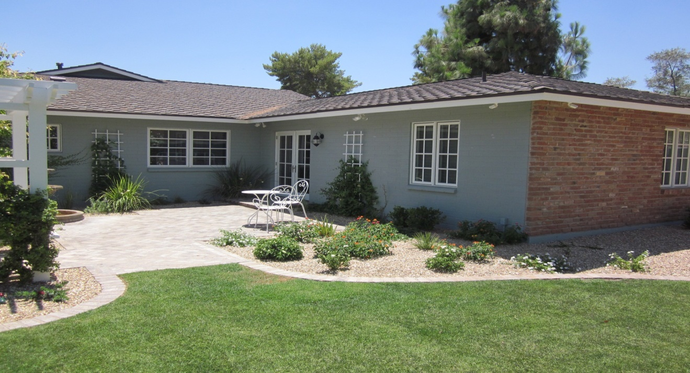

Kiah & Vanessa
520-603-6888
Kiah works nights. Text
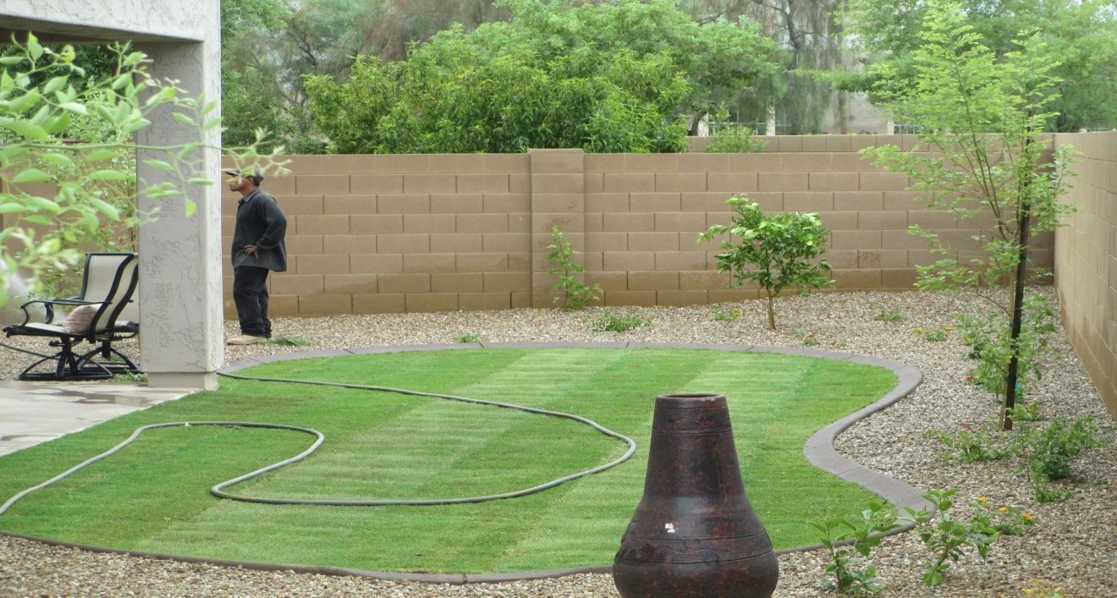

John Riskas
Owner Riskas Construction (Florida)
3605 E. Camelback Rd.
Phoenix , AZ 85013
561-654-6842 he likes an actual phone call

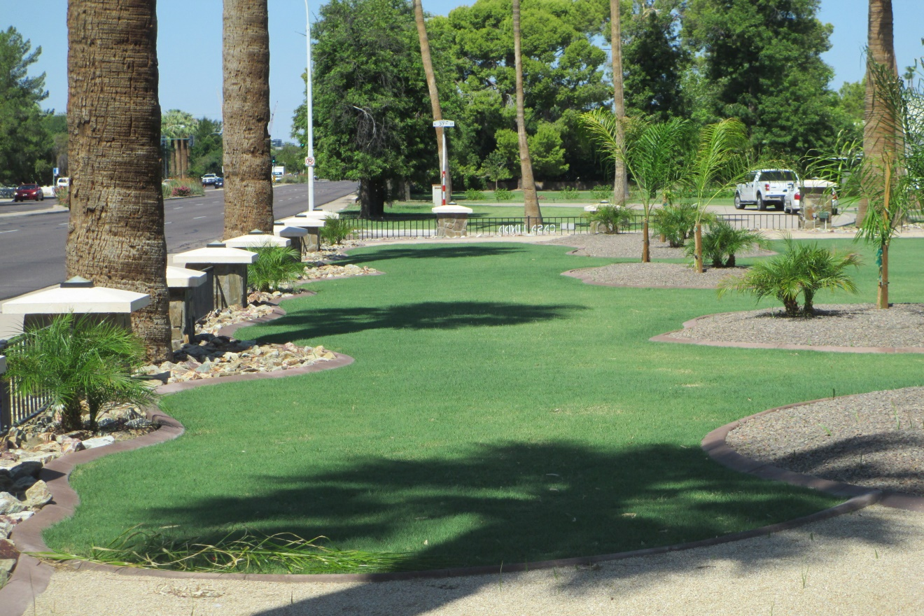

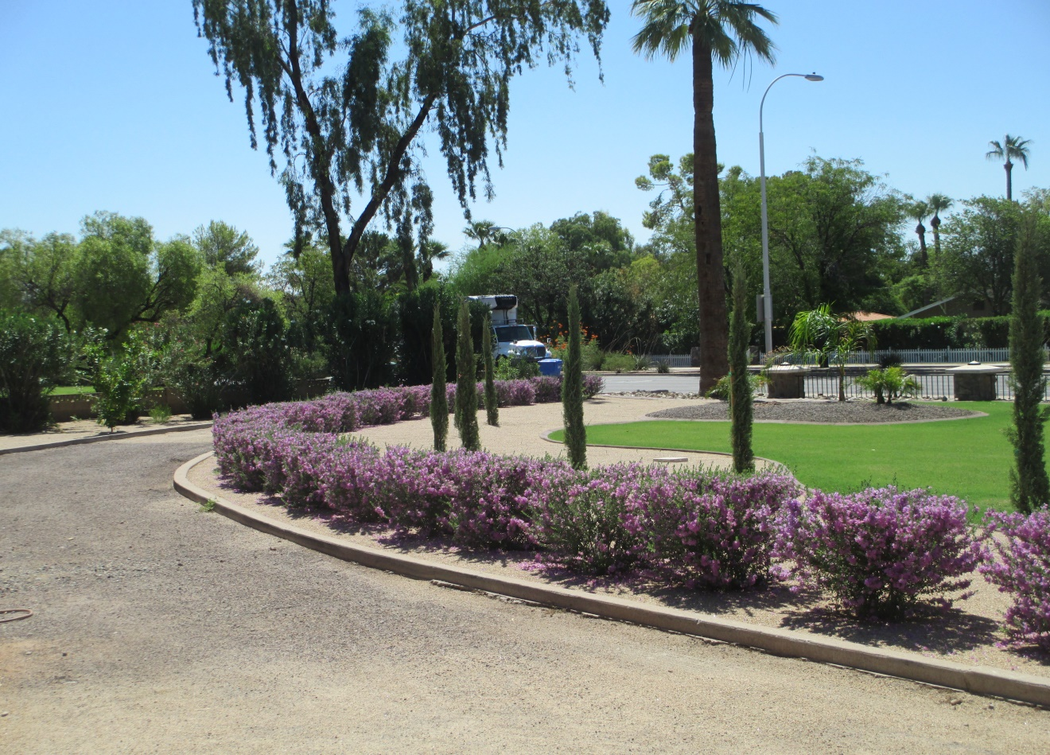
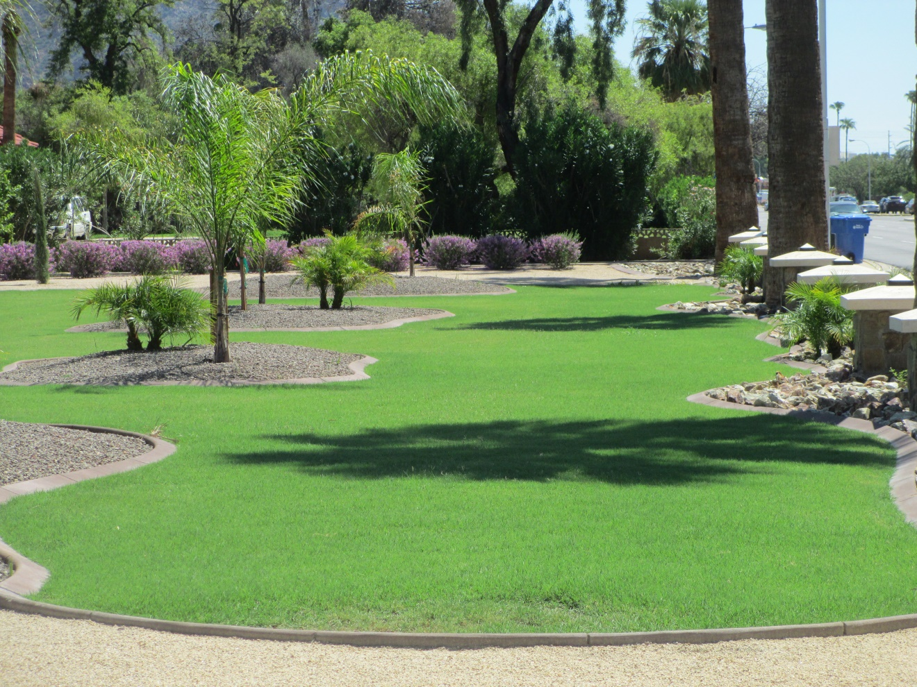
Jeff & Lynne Winkler
4376 R Anderson Drive
Phoenix, AZ 85032.
480-236-2283

Really cool folks. Jeff had me twice for Pavers & to make the pool area much more Tropical
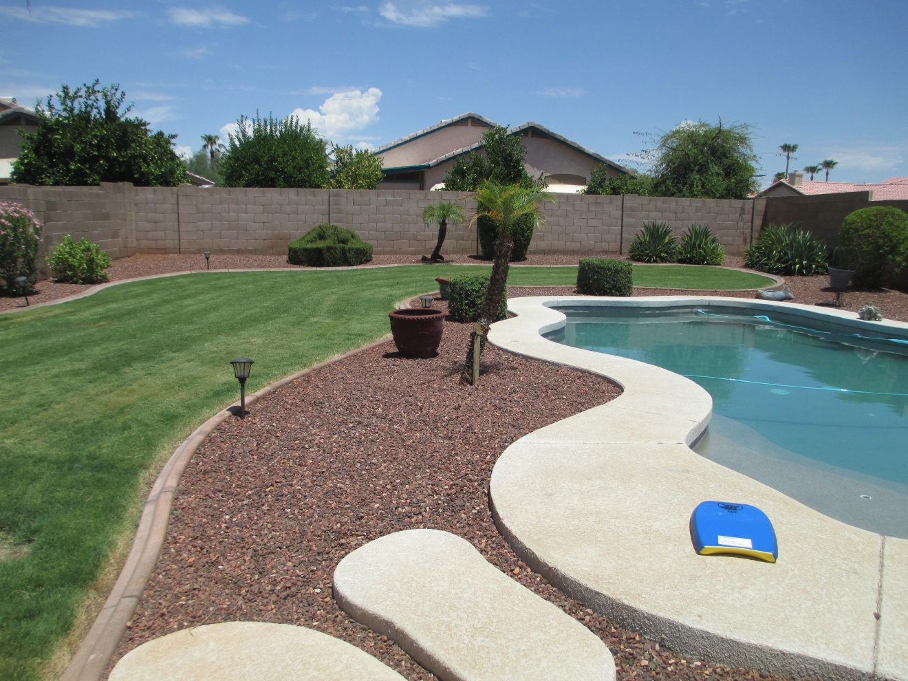
Before
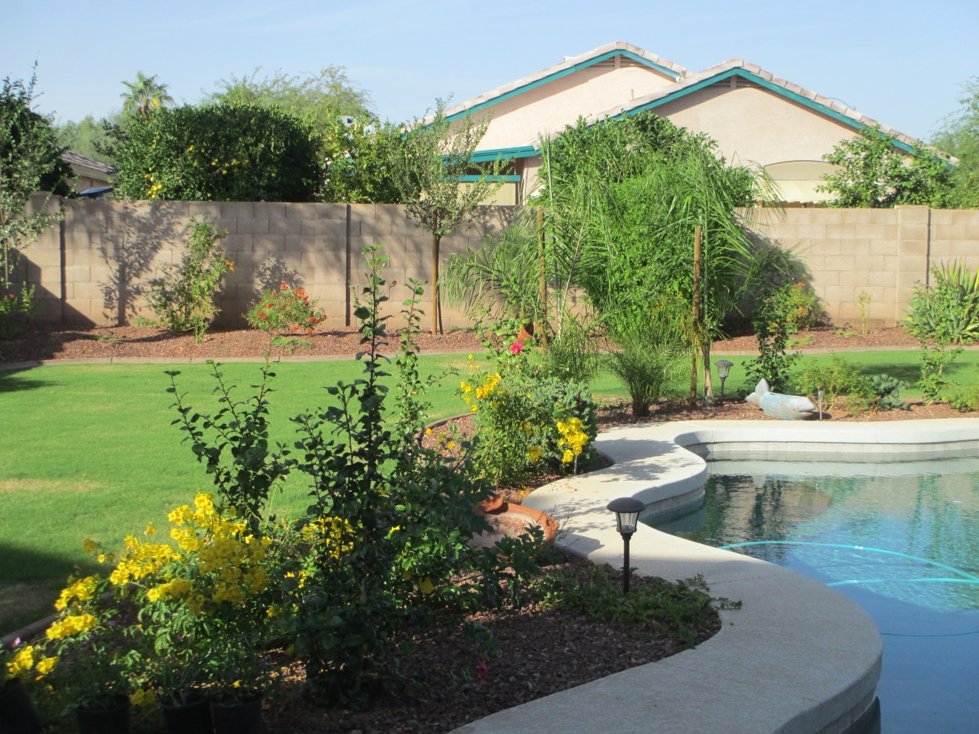
After

I submit with respect,

Larry Thomas 623-329-3169

www.LarryLandScapeS.com

